Pperational Amplifier

6.18 a Main Question (สำหรับแสดงข้อสอบ)

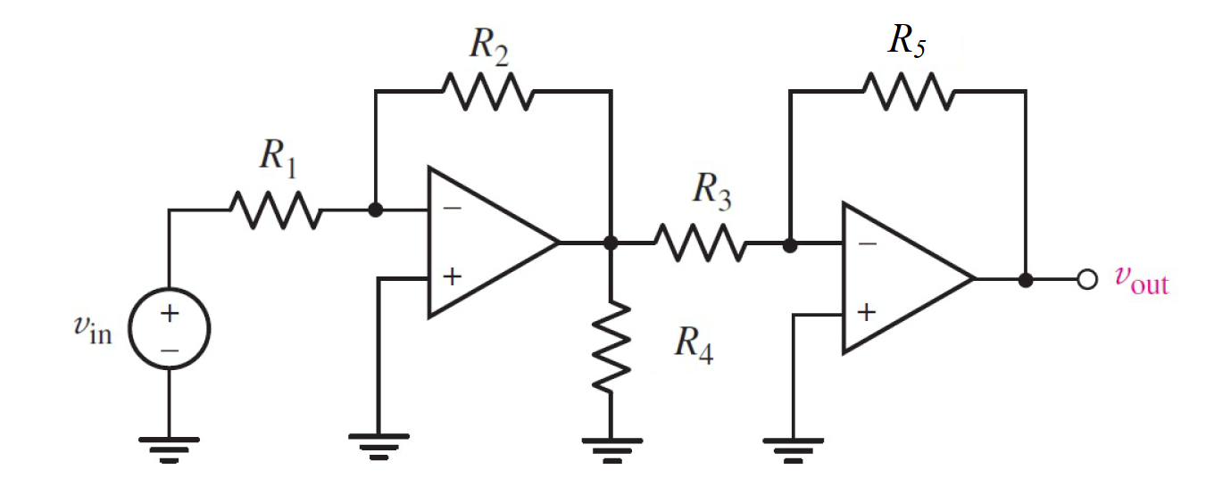

Given *V*in = 2 V,

*R*1 = 10 Ω, *R*2 = 5 Ω, *R*3 = 1000 Ω,

*R4* = 10 Ω, *R*5 = 2000 Ω,

Find

Variables (สำหรับเขียนโค้ดเพื่อหาคำตอบ)

Random variables

Vs = {2:10};

R1 = {2:10};

R2 = {2:10};

R3 = {1000:10000:1000};

R5 = {1000:10000:1000};

Global variables

#Vs = 2;

R1 = 10; R2 = 5; R3 = 1000; R4 = 10;

R5 = 2000;

VOUT = Vs*(R2/R1)*(R5/R3);

Part (กรอกคำตอบ)

1. Vout = VOUT = 2 V

6.20 a Main Question (สำหรับแสดงข้อสอบ)

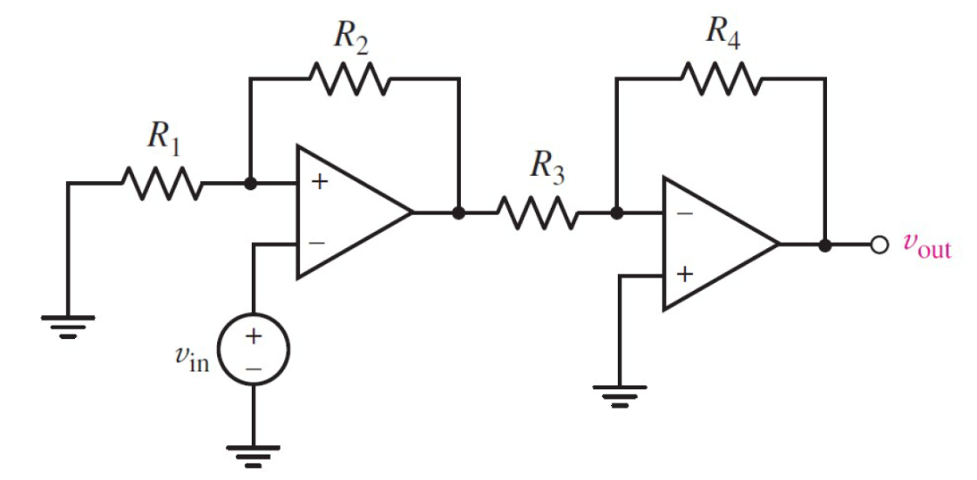

Given *V*in = 0.3 V,

*R*1 = 10 Ω, *R*2 = 15 Ω, *R*3 = 2000 Ω,

*R4* = 5000 Ω

Find

Variables (สำหรับเขียนโค้ดเพื่อหาคำตอบ)

Random variables

Vs = {1:10:0.1};

R1 = {2:10};

R2 = {2:20};

R3 = {1000:10000:1000};

R4 = {1000:10000:1000};

Global variables

#Vs = 0.3;

R1 = 10; R2 = 15; R3 = 2000; R4 = 5000;

VOUT = -Vs*(1+R1/R2)*(R4/R3);

Part (กรอกคำตอบ)

1. Vout = VOUT = -1.25 V

6.21 a Main Question (สำหรับแสดงข้อสอบ)

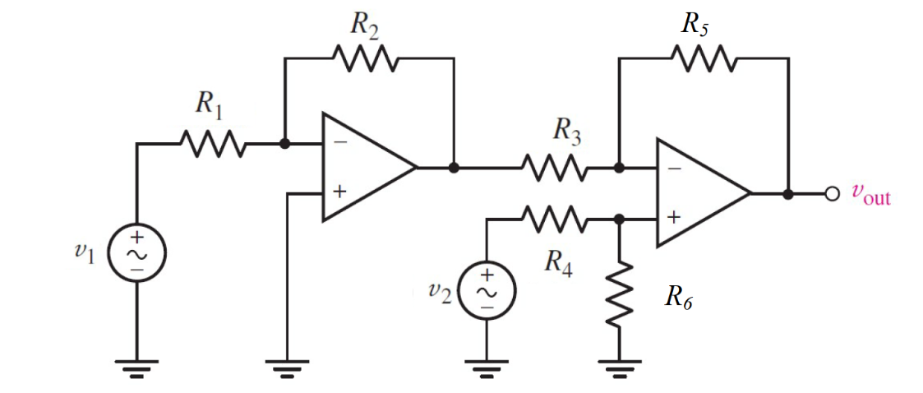

Given *V*1 = 2.2 V, *V*2 = 1.1 V,

*R*1 = 10 Ω, *R*2 = 15 Ω, *R*3 = 2000 Ω,

*R4* = 5000 Ω, *R5* = 5000 Ω, *R6* = 5000 Ω

Find

Variables (สำหรับเขียนโค้ดเพื่อหาคำตอบ)

Random variables

V1 = {1:10:0.5}; V2 = {2:10};

R1 = {100:20000};

R2 = {2:20};

R3 = {1000:10000:1000};

R4 = {1000:10000:1000};

R5 = {1000:10000:1000};

Global variables

# V1 = 1.5; V2 = 1;

R1 = 500; R2 = 1500; R3 = 5000; R4 = 5000;

R5 = 5000; R6 = 5000;

V=(V2/R4)/(1/R4+1/R6);

VOUT = V*(1+R5/R3)-(R5/R3)*(-R2/R1)*V1;

Part (กรอกคำตอบ)

1. Vout = VOUT = 5.5 V

6.23 a Main Question (สำหรับแสดงข้อสอบ)

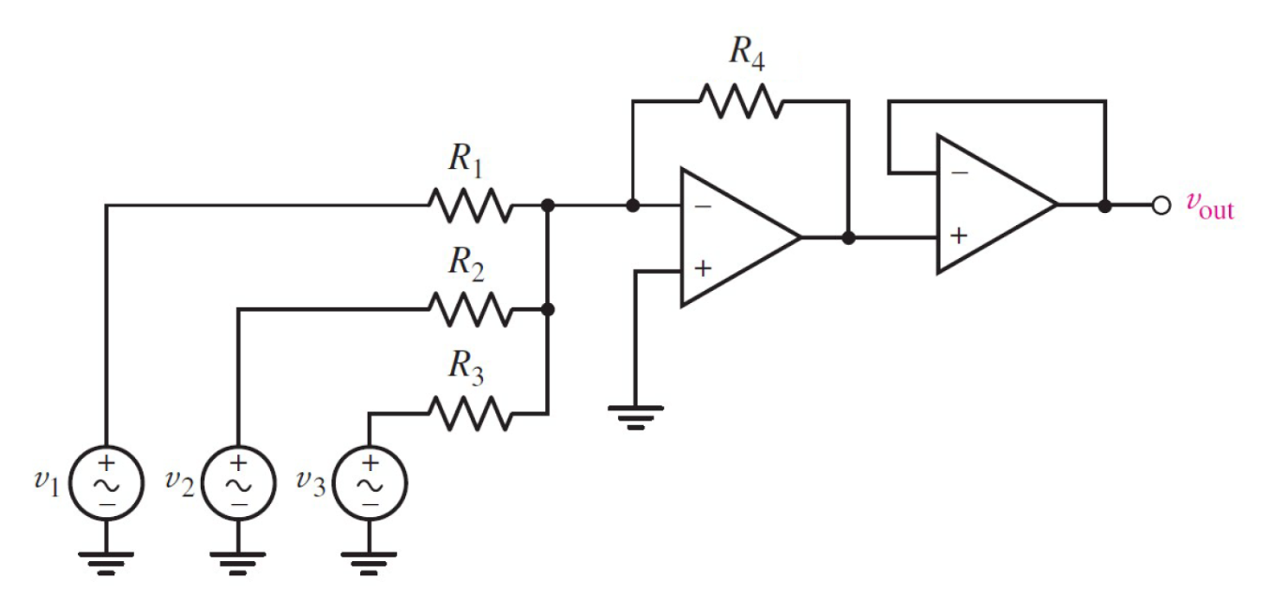

Given *V*1 = 2.2 V, *V*2 = 1.1 V, *V*3 = 4.4 V,

*R*1 = 50,000 Ω, *R*2 = 50,000 Ω, *R*3 = 50,000 Ω,

*RF* = 200000 Ω

Find

Variables (สำหรับเขียนโค้ดเพื่อหาคำตอบ)

Random variables

V1 = {2:10}; V2 = {2:10}; V3 = {2:10};

R1 = {20000:100000:1000};

R2 = {20000:100000:1000};

R3 = {20000:100000:1000};

Global variables

#V1 = 2.2; V2 = 1.1; V3 = 4.4;

#R1 = 50000; R2 = 50000; R3 = 50000;

R4 = 200000;

VOUT = -RF*(V1/R1+V2/R2+V3/R3)

Part (กรอกคำตอบ)

1. Vout = VOUT = -30.8 V

6.28 a Main Question (สำหรับแสดงข้อสอบ)

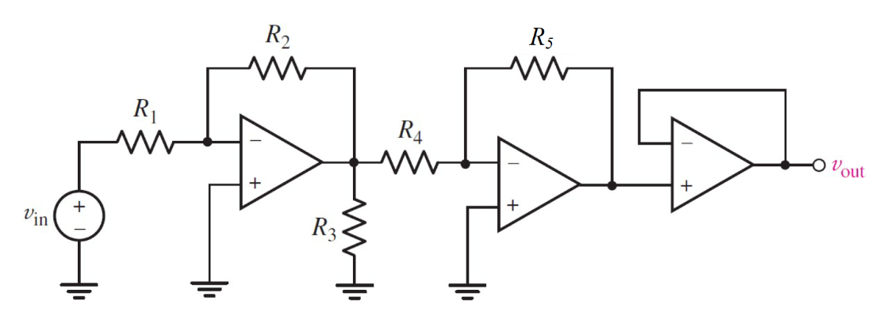

Given *V*in = 8 V,

*R*1 = 8000 Ω, *R*2 = 1000 Ω, *R*3 = 1000 Ω,

*R4* = 50000 Ω, *R5* = 200000 Ω,

Find

Variables (สำหรับเขียนโค้ดเพื่อหาคำตอบ)

Random variables

V1 = {1:10:0.5}; V2 = {2:10};

R1 = {100:20000};

R2 = {2:20};

R3 = {1000:10000:1000};

R4 = {1000:10000:1000};

R5 = {1000:10000:1000};

Global variables

# Vs = 8;

R1 = 8000; R2 = 1000; R3 = 1000; R4 = 50000;

R5 = 200000;

VOUT = (R2/R1)*(R5/R4)*Vs;

Part (กรอกคำตอบ)

1. Vout = VOUT = 4 V